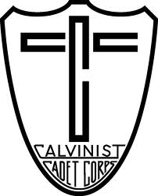AOBMC hosted by Berean Council
March 3, 2012

Discipline to Discipleship
“Helping boys to be more Christ-like in all areas of life”

1. Definitions
Discipline:

Discipleship:

2. Experiences
What are some discipline issues/struggles you’ve had in your club?

Video: While you are watching…
Think about 1 or 2 discipline problems in the video that you can relate to.

Write down some ways that discipline problems can be prevented.

3. Big Questions

Who are the boys following?

How are we leading? What can we do to become more effective leaders?

4. Practical Steps

What can we do to prevent discipline problems in our clubs?

Restorative Justice
- What happened?
- How did it happen?
- What part did you play in it?
- How were you affected/who was affected?
- What do you need to make it right?
- How can we repair the harm?

Your turn: In groups of 2, you will be doing a role play. Choose one of the problems from our discipline experiences. One person will be the Cadet, the other person will be the Head Counselor. Practice your role play and be prepared to present it to the group.

